Game rules

When the game starts, it is paused which means none of the physics are happening. The player then has the three options they can interact with in a small menu at the top of the screen: Play, Fan and Magnet. The fan and magnet can be dragged and snapped into the dotted line slots.

Pressing the **play button** activates the physics and starts moving around the robot according to what the player placed, if the player presses play without having placed anything things like the conveyor belt start making noise but it should be immediately obvious that you need to interact with the other buttons.

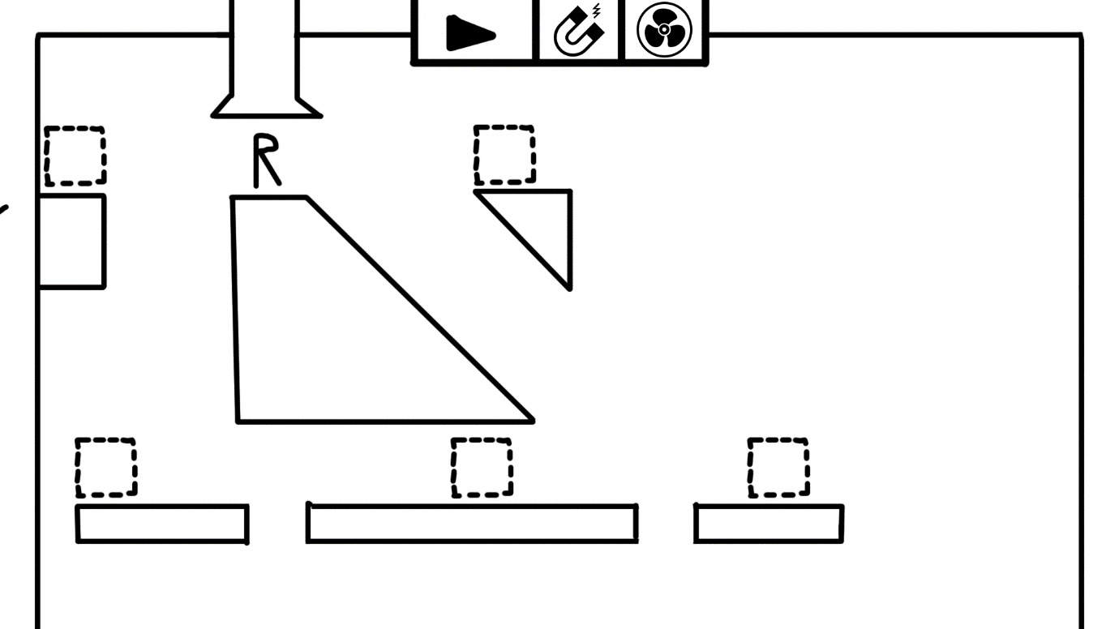

Placing an **object** like the fan or the magnet should make it automatically point in the direction of the player. However the objects applying it’s force in both directions around it is also just fine. Dragging these objects down from the menu should snap them into the sockets.  
The **fan** object pushes the player away from it and the **magnet** object pulls the player towards it. Usually, these objects will have a hole between the player and the object which the player will **fall** down, because **gravity should be stronger than the pull of the objects**. In case the player places a magnet and a fan opposite of each other, **the magnet should take priority over the fan.**

There’s a third object which can’t be placed by the players, which is **conveyor belts** which move the player in a set direction.

The **camera** moves with the player as he falls down and as soon as the camera moves the menu disappears until the camera stops moving again. The menu disappears when the camera starts moving as well, to signify that the player has no control over what happens in this moment. Once the robot is still again the menu comes back down.

There’s a lot of fake choice in the levels, as no matter what you press you will get to the part but there’s different routes you can take depending on the magnet or the fan to make it seem to the player that their choices did impact the route the robot takes, it will however always lead to the part no matter what the player actually did.

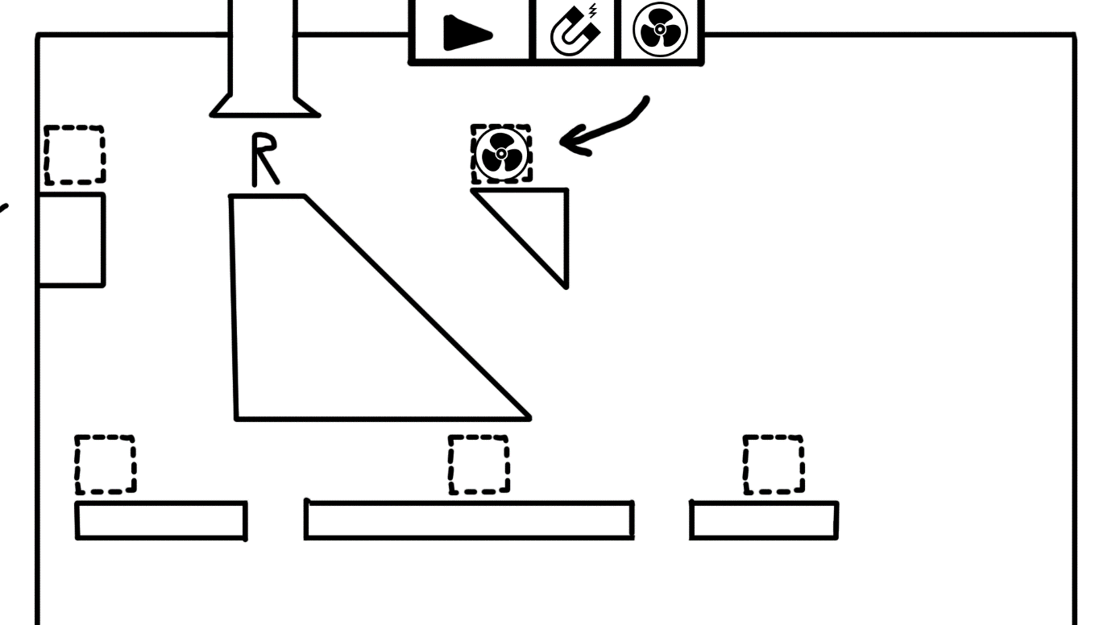So once the player drags an item in, it should snap to the sockets and point towards the player(It’s OK if it just applies its force in both directions as well)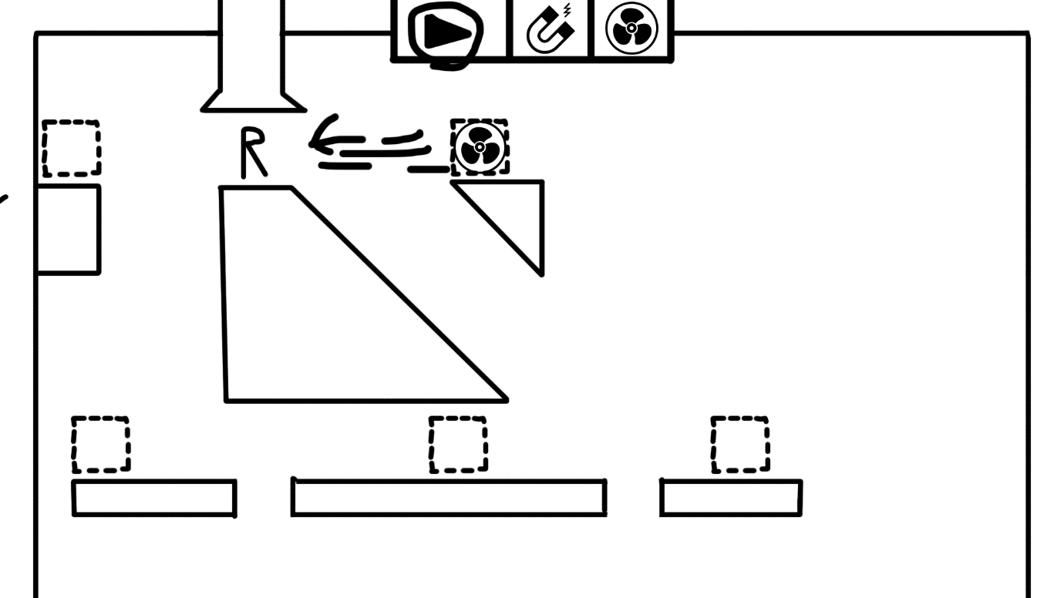

Pressing play starts applying the forces of the objects the player placed and starts pulling and moving the robot. As soon as it goes over an edge it should start falling down, with some directional force still applied.

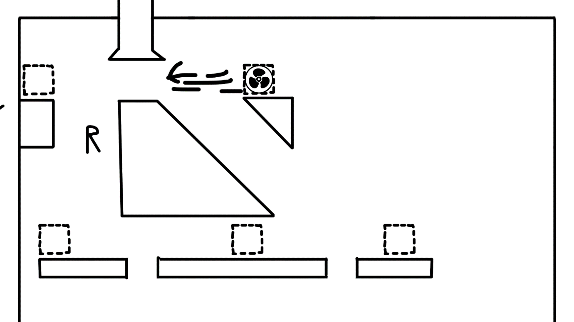

The player starts falling down and the UI disappears to signify that the player has no control over what happens right now.

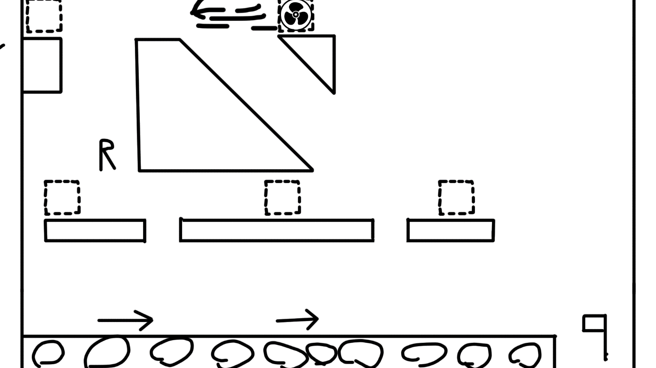

The camera also starts moving as soon as the player falls and starts revealing more stuff further down in the level.

The directions come together again when there is a part, and this pattern of splitting and coming together continues for a while until finally the 3rd part is collected and the now finished robot gets sent out the right side and continues the chain reaction.